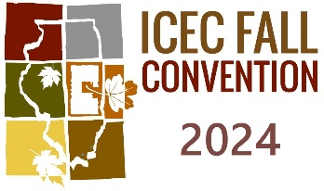

ADVERTISING IN THE ILLINOIS CEC FALL CONVENTION PROGRAM 2024

Type of advertisements: Advertisements in the ICEC Fall Convention Program 2024 that support the lives and work of special education teachers and related service professionals, and their students are welcome.
- Deadline for submitting advertising copy is Friday, September 13, 2024.
- Copy must be camera ready.
- Copy size will be: Full Page 8”x10” Half Page 8”x5” Quarter Page 8’’x2½”
- Black and White Only!
Please reserve advertisement space in the ICEC Annual Fall Convention Program, 2024

Advertising Rates: Full Page $200.00 Half Page $100.00 Quarter Page $50.00
Online Payment Option: https://www.illinoiscec.net/convention-call-for-proposals/icec-exhibits-advertisements/
US Mail Option: ICEC Fall Convention, P.O. Box 324, Normal, IL 61761
Check #___________ in the amount of $ ________

NAME OF FIRM: ________________________________________________________________

ADDRESS: _____________________________________________________________________

CITY: _________________________________ STATE: ______________ ZIP: ______________

AGENT’S SIGNATURE: __________________________________________________________________

E-Mail: ______________________________________________________________________________
CAMERA READY COPY ENCLOSED: _______ CAMERA READY COPY TO FOLLOW: ____________
Email a copy of your advertisement to: Nikki Michalak <nakempe@ilstu.edu>
For further inquiries about advertisements in the ICEC Fall Convention Program
email Nikki Michalak <nakempe@ilstu.edu>

